CAP 4611 Assignment 1
Cameron D Lewis
UCFID 5593788
Section 01
09/02/25

1. Linear Algebra Review
1.1Basic Operations
1. $14$
2. $0$
3. $⟦\begin{matrix}2 \\ 10 \\ 0\end{matrix}⟧$
4. $\sqrt{5}$
5. $⟦\begin{matrix}6 \\ 5 \\ 7\end{matrix}⟧$
6. $19$
7. $⟦\begin{matrix}11 & 10 & 10 \\ 10 & 14 & 10 \\ 10 & 10 & 14\end{matrix}⟧$
  - Matrix Algebra Rules
1. $True$
2. $True$
3. $False$
4. $True$
5. $False$
6. $True$
7.$False$
8. $True$
9. $True$
10. $False$
- Probability Review
  - Rules of Probability
1. $10$
2. $0.55$
3. $0.917$
  - Bayes Rule and Conditional Probability
1. $1\%$
2. false positives
3. $<1\%$
4. No
5. try to lower false positives
3. Calculus Review
  - One Variable Derivatives
1.$15x^{2}-2$
2.$1-2x$
3.$\frac{1}{1+e^{-x}}$
  - Multivariable Derivatives
1.$\left(\begin{matrix}. {2x}_{1}+e^{x_{1}+{3x}_{2}} \\ {3e}^{x_{1}+{3x}_{2}}\end{matrix}\right)$
2.$\frac{1}{Z}\left(\begin{matrix}e^{x_{1}} \\ e^{x_{2}} \\ e^{x_{3}}\end{matrix}\right)$

3. a
4. $\left(\begin{matrix}4x_{1}-x_{2} \\ -x_{1}+4x_{2}\end{matrix}\right)$
5. x

  - Optimization
- $\frac{14}{3}$

- $\frac{1}{4}$

- 0

- $\frac{1}{2}$

- 1

- (0,0)

  - Derivatives of Code
1.

def foo_grad(x):
λ = 4
return λ * x ** (λ - 1)

def bar_grad(x):
grad=np.empty_like(x)
totalProd = np.prod(x)
for i in range(len(x)):
if x[i] !=0:
grad[i] = totalProd / x[i]
else :
grad[i] = np.prod(np.delete(x, i))
return grad

- Algorithms and Data Structures Review

  - Trees
- 7

- 7

  - Common Runtimes
- O(n)

- O(lgn)

- O(1)

- O(d)

- O(dxd)

  - Running times of code
1. O(n)
2. O(n)
3. O(1)
4. O($n^{2}$)

- Data Exploration
1.

  - Summary Statistics

** min: 0.352000 **
** max: 4.862000 **
** mean: 1.324625 **
** median: 1.1589999999999998 **
** mode: 0.77 **
2.
** 5th percentile: 0.46495000000000003 **
** 25th percentile: 0.718 **
** 50th percentile: 1.1589999999999998 **
** 75th percentile: 1.81325 **
** 95th percentile: 2.624049999999999 **

3.
** Highest Mean: WtdILI **
** Lowest Mean: Pac **
** Highest Variance: Mtn **
** Lowest Variance: Pac **
4.
No, the mode is not a reliable estimate of the most common value because the data set is a continuous one a better way to find this would be to use a histogram

  - Data Visualization
1. D because it displays a frequency distribution using vertical bars with many categories at each x increment

2. C because it displays a frequency distribution using vertical bars

- B there is only one box plot and it has IQR boxes

- A has illness percentages going up or down by city as the weeks progress

- F points are closer together higher correlation

6. E points are more spread out lower correlation

- Decision Trees
6.1 Splitting Rule
1. The threshold-based split is better for categorical features, while the equality-based split is better for continuous features
6.2 Decision Stump Implementation
class DecisionStumpErrorRate:
y_hat_yes = None
y_hat_no = None
j_best = None
t_best = None
def fit(self, X, y):
n, d = X.shape
count = np.bincount(y)
y_mode = np.argmax(count)
self.y_hat_yes = y_mode
self.y_hat_no = None
self.j_best = None
self.t_best = None
if np.unique(y).size <= 1:
return
minError = np.sum(y != y_mode)
# Loop over features looking for the best split
for j in range(d):
for i in range(n):
# Choose value to equate to
t = np.round(X[i, j])
is_almost_equal = (X[:, j] >= t - 3) & (X[:, j] <= t + 3)
y_yes_mode = utils.mode(y[is_almost_equal])
y_no_mode = utils.mode(y[~is_almost_equal]) # ~ is "logical not"
# Make predictions
y_pred = y_yes_mode * np.ones(n)
y_pred[~is_almost_equal] = y_no_mode
# Compute error
errors = np.sum(y_pred != y)
# Compare to minimum error so far
if errors < minError:
minError = errors
self.j_best = j
self.t_best = t
self.y_hat_yes = y_yes_mode
self.y_hat_no = y_no_mode
def predict(self, X):
n, d = X.shape
X = np.round(X)
if self.j_best is None:
return self.y_hat_yes * np.ones(n)
y_hat = np.zeros(n)
for i in range(n):
if self.t_best - 3 <= X[i, self.j_best] <= self.t_best + 3:
y_hat[i] = self.y_hat_yes
else:
y_hat[i] = self.y_hat_no
return y_hat
1. error .245
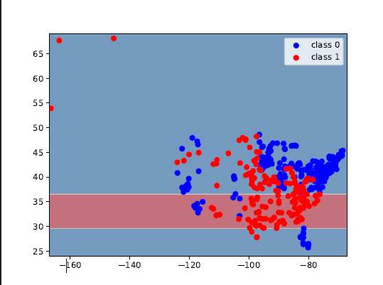

  - Decision Stump Info Gain Implementation
1.
class DecisionStumpInfoGain(DecisionStumpErrorRate):
# This is not required, but one way to simplify the code is
# to have this class inherit from DecisionStumpErrorRate.
# Which methods (init, fit, predict) do you need to overwrite?
y_hat_yes = None
y_hat_no = None
j_best = None
t_best = None
"""YOUR CODE HERE FOR Q6.3"""
def fit(self, X, y):
n, d = X.shape
n_classes = len(np.unique(y))
# Calculate total entropy
counts = np.bincount(y, minlength=n_classes)
total_entropy = entropy(counts / counts.sum())
max_info_gain = -1
self.y_hat_yes = None
self.y_hat_no = None
self.j_best = None
self.t_best = None
# Try all features and thresholds
for j in range(d):
feature = X[:, j]
thresholds = np.unique(feature)
for t in thresholds:
yes_mask = feature >= t
no_mask = ~yes_mask
y_yes = y[yes_mask]
y_no = y[no_mask]
# Skip if one side is empty
if len(y_yes) == 0 or len(y_no) == 0:
continue
# Calculate entropy for each split
counts_yes = np.bincount(y_yes, minlength=n_classes)
counts_no = np.bincount(y_no, minlength=n_classes)
h_yes = entropy(counts_yes / counts_yes.sum())
h_no = entropy(counts_no / counts_no.sum())
# Calculate weighted average entropy
weighted_entropy = (len(y_yes) * h_yes + len(y_no) * h_no) / n
# Calculate information gain
info_gain = total_entropy - weighted_entropy
# Update best split \
if info_gain > max_info_gain:
max_info_gain = info_gain
self.j_best = j
self.t_best = t
self.y_hat_yes = utils.mode(y_yes)
self.y_hat_no = utils.mode(y_no)
def predict(self, X):
n = X.shape[0]
if self.j_best is None:
return np.zeros(n)
y_hat = np.zeros(n)
yes_mask = X[:, self.j_best] >= self.t_best
y_hat[yes_mask] = self.y_hat_yes
y_hat[~yes_mask] = self.y_hat_no
return y_hat

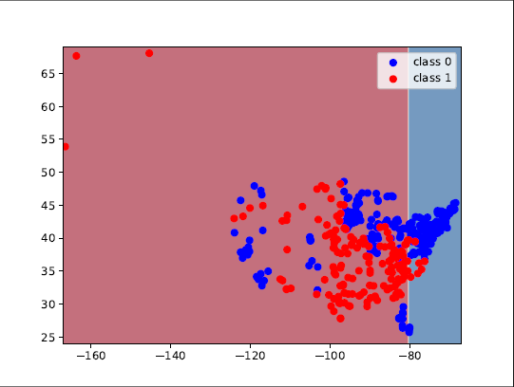
In 6.3 I get a higher error value but it gets back to the same as 6.2 when used on 6.4
6.4 Hard Coded Decision Trees
1. Before hard coding
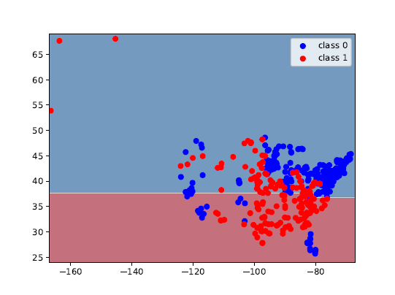

  - Decision Tree Training Error
1.

2.

3.

  - Comparing Implementations
1.

